**FIND WHICH EXTENSION IS ALLOW TO BE UPLOADED**

We're going to use Intruder (used for automating customised attacks).

To begin, make a wordlist with the following extensions in:

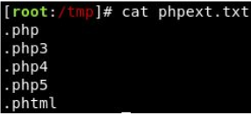

Now make sure BurpSuite is configured to intercept all your browser traffic. Upload a file, once this request is captured, send it to the Intruder. Click on "Payloads" and select the "Sniper" attack type.

Click the "Positions" tab now, find the filename and "Add §" to the extension. It should look like so:

